UNIT II
RECTIFIERS & FILTERS:

2.0 INTRODUCTION

For the operation of most of the electronics devices and circuits, a d.c. source is required. So it is advantageous to convert domestic a.c. supply into d.c.voltages. The process of converting a.c. voltage into d.c. voltage is called as rectification. This is achieved with i) Step-down Transformer, ii) Rectifier, iii) Filter and iv) Voltage regulator circuits.
These elements constitute d.c. regulated power supply shown in the fig 1 below.
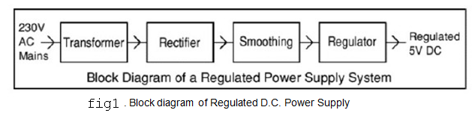
- Transformer – steps down 230V AC mains to low voltage AC.
- Rectifier – converts AC to DC, but the DC output is varying.
- Smoothing – smooth the DC from varying greatly to a small ripple.
- Regulator – eliminates ripple by setting DC output to a fixed voltage.

The block diagram of a regulated D.C. power supply consists of step-down transformer, rectifier, filter, voltage regulator and load. An ideal regulated power supply is an electronics circuit designed to provide a predetermined d.c. voltage Vo which is independent of the load current and variations in the input voltage ad temperature. If the output of a regulator circuit is a AC voltage then it is termed as voltage stabilizer, whereas if the output is a DC voltage then it is termed as voltage regulator.

2.1 RECTIFIER:
Any electrical device which offers a low resistance to the current in one direction but a high resistance to the current in the opposite direction is called rectifier. Such a device is capable of converting a sinusoidal input waveform, whose average value is zero, into a unidirectional Waveform, with a non-zero average component. A rectifier is a device, which converts a.c. voltage (bi-directional) to pulsating d.c. voltage (Unidirectional).

Characteristics of a Rectifier Circuit:
Any electrical device which offers a low resistance to the current in one direction but a high resistance to the current in the opposite direction is called rectifier. Such a device is capable of converting a sinusoidal input waveform, whose average value is zero, into a unidirectional waveform, with a non-zero average component.

A rectifier is a device, which converts a.c. voltage (bi-directional) to pulsating d.c..Load currents: They are two types of output current. They are average or d.c. current and RMS currents.

Average or DC current: The average current of a periodic function is defined as the area of one cycle of the curve divided by the base.
It is expressed mathematically as

- Average value/dc value/mean value=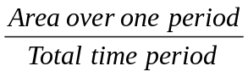
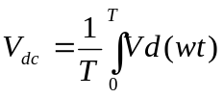

ii) Effective (or) R.M.S current:

The effective (or) R.M.S. current squared ofa periodic function of time is given by the area of one cycle of the curve, which represents the square of the function divided by the base.

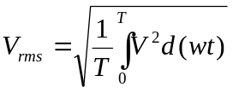

iii) Peak factor:
It is the ratio of peak value to Rms value
Peak factor =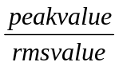

iv) Form factor:
It is the ratio of Rms value to average value
Form factor=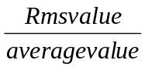

v) Ripple Factor () : It is defined as ration of R.M.S. value of a.c. component to the d.c. component in the output is known as “Ripple Factor”.
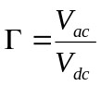
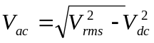
vi) Efficiency ():

It is the ratio of d.c output power to the a.c. input power. It signifies, how efficiently the rectifier circuit converts a.c. power into d.c. power.
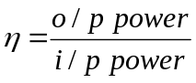

vii) Peak Inverse Voltage (PIV):
It is defined as the maximum reverse voltage that a diode can withstand without destroying
the junction.

viii) Transformer Utilization Factor (UTF):

The d.c. power to be delivered to the load in a rectifier circuit decides the rating of the
Transformer used in the circuit. So, transformer utilization factor is defined as

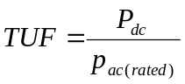

ix) % Regulation:

The variation of the d.c. output voltage as a function of d.c. load current is called regulation. The percentage regulation is defined as

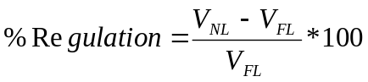

For an ideal power supply, % Regulation is zero.

2.2 CLASSIFICATION OF RECTIFIERS:
Using one or more diodes in the circuit, following rectifier circuits can be designed.

1) Half - Wave Rectifier
2) Full – Wave Rectifier
3) Bridge Rectifier

2.2.1) HALF-WAVE RECTIFIER:
A Half – wave rectifier as shown in fig 2 is one, which converts a.c. voltage into a pulsating voltage using only one half cycle of the applied a.c. voltage.

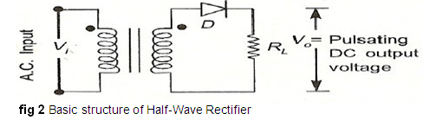

The a.c. voltage is applied to the rectifier circuit using step-down transformer-rectifying element i.e., p-n junction diode and the source of a.c. voltage, all connected is series. The a.c. voltage is applied to the rectifier circuit using step-down transformer

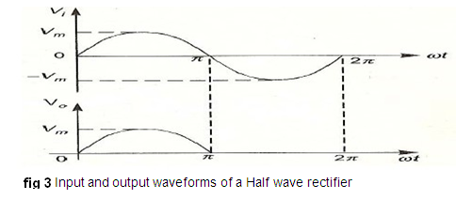

V=V_{m} sin (wt)
The input to the rectifier circuit, Where V_{m} is the peak value of secondary a.c. voltage.

Operation:
For the positive half-cycle of input a.c. voltage, the diode D is forward biased and hence it conducts. Now a current flows in the circuit and there is a voltage drop across RL. The waveform of the diode current (or) load current is shown in fig 3.
For the negative half-cycle of input, the diode D is reverse biased and hence it does not
Conduct. Now no current flows in the circuit i.e., i=0 and Vo=0. Thus for the negative half- cycle no power is delivered to the load.

Analysis:

In the analysis of a HWR, the following parameters are to be analyzed.

- DC output current
- DC Output voltage
- R.M.S. Current
- R.M.S. voltage
- Rectifier Efficiency (η )
- Ripple factor (γ )
- Peak Factor
- % Regulation
- Transformer Utilization Factor (TUF)
- form factor
- o/p frequency

Let a sinusoidal voltage Vi be applied to the input of the rectifier.
Then V=V_{m} sin (wt) Where V_{m} is the maximum value of the secondary voltage. Let the diode be idealized to piece-wise linear approximation with resistance Rf in the forward direction i.e., in the ON state and Rr (=∞) in the reverse direction i.e., in the OFF state. Now the current ‘i’ in the diode (or) in the load resistance RL is given by V=V_{m} sin (wt)

i) AVERAGE VOLTAGE

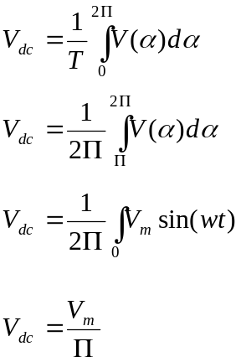
ii).AVERAGE CURRENT:
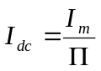
iii) RMS VOLTAGE:
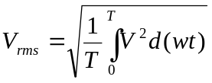
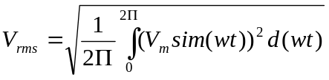

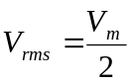

IV) RMS CURRENT
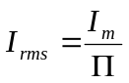

V) PEAK FACTOR
Peak factor =
Peak Factor =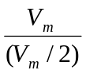
Peak Factor =2
vi) FORM FACTOR
Form factor=
Form factor= 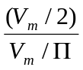
Form Factor =1.57

vii) Ripple Factor:
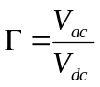
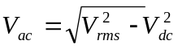
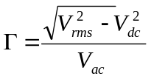
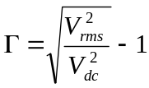
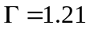

viii) Efficiency ():

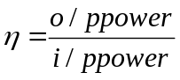*100
=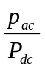*100
=40.8

ix) Transformer Utilization Factor (TUF):
The d.c. power to be delivered to the load in a rectifier circuit decides the rating of the transformer used in the circuit. Therefore, transformer utilization factor is defined as
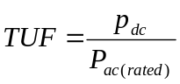
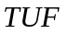=0.286.
The value of TUF is low which shows that in half-wave circuit, the transformer is not fully utilized.
If the transformer rating is 1 KVA (1000VA) then the half-wave rectifier can deliver
1000 X 0.287 = 287 watts to resistance load.

x) Peak Inverse Voltage (PIV):

It is defined as the maximum reverse voltage that a diode can withstand without destroying the junction. The peak inverse voltage across a diode is the peak of the negative half- cycle. For half-wave rectifier, PIV is Vm.

DISADVANTAGES OF HALF-WAVE RECTIFIER:

1. The ripple factor is high.
2. The efficiency is low.
3. The Transformer Utilization factor is low.
Because of all these disadvantages, the half-wave rectifier circuit is normally not used as a
power rectifier circuit.

2.2.2) FULL WAVE RECTIFIER:
A full-wave rectifier converts an ac voltage into a pulsating dc voltage using both half cycles of the applied ac voltage. In order to rectify both the half cycles of ac input, two diodes are used in this circuit. The diodes feed a common load RL with the help of a center-tap transformer. A center-tap transformer is the one, which produces two sinusoidal waveforms of same magnitude and frequency but out of phase with respect to the ground in the secondary winding of the transformer. The full wave rectifier is shown in the fig 4 below
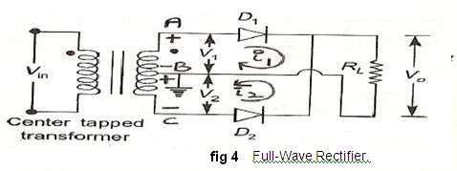

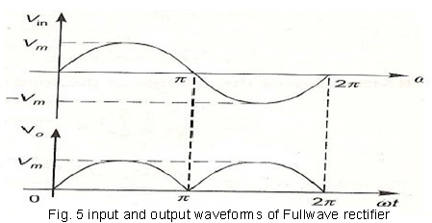
Fig. 5 shows the input and output wave forms of the ckt.
During positive half of the input signal, anode of diode D1 becomes positive and at the
same time the anode of diode D2 becomes negative. Hence D1 conducts and D2 does not
conduct. The load current flows through D1 and the voltage drop across RL will be equal to the input voltage.
During the negative half cycle of the input, the anode of D1 becomes negative and the anode of D2 becomes positive. Hence, D1 does not conduct and D2 conducts. The load current flows through D2 and the voltage drop across RL will be equal to the input voltage. It is noted that the load current flows in the both the half cycles of ac voltage and in the same direction through the load resistance.

- AVERAGEVOLTAGE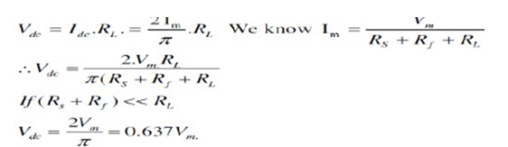

- AVERAGE CURRENT

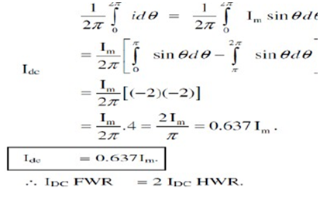
iii) RMS VOLTAGE:
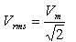

IV) RMS CURRENT
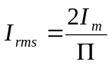

V) PEAK FACTOR
Peak factor =
Peak Factor =
Peak Factor =2
vi) FORM FACTOR
Form factor=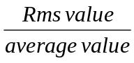
Form factor= 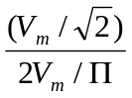
Form Factor =1.11
vii) Ripple Factor:
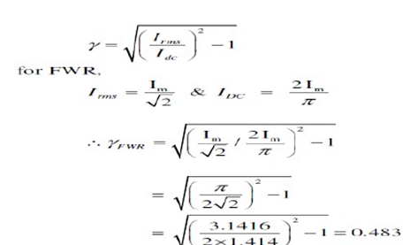
viii) Efficiency ():

*100
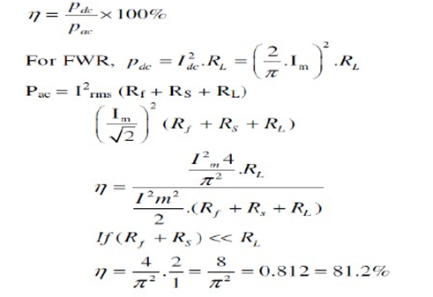

ix) Transformer Utilization Factor (TUF):

The d.c. power to be delivered to the load in a rectifier circuit decides the rating of the transformer used in the circuit. So, transformer utilization factor is defined as
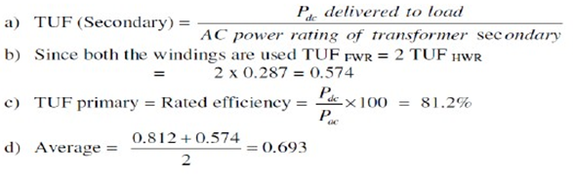

x) Peak Inverse Voltage (PIV):

It is defined as the maximum reverse voltage that a diode can withstand without destroying the junction. The peak inverse voltage across a diode is the peak of the negative half- cycle. For half- wave rectifier, PIV is 2Vm

xi) % Regulation
.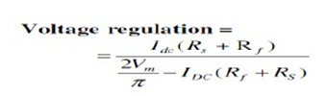
Advantages

1) Ripple factor = 0.482 (against 1.21 for HWR)
2) Rectification efficiency is 0.812 (against 0.405 for HWR)
3) Better TUF (secondary) is 0.574 (0.287 for HWR)
4) No core saturation problem
Disadvantages:
- Requires center tapped transformer.

2.2.3) BRIDGE RECTIFIER.
Another type of circuit that produces the same output waveform as the full wave rectifier circuit above, is that of the Full Wave Bridge Rectifier. This type of single phase rectifier uses four individual rectifying diodes connected in a closed loop "bridge" configuration to produce the desired output. The main advantage of this bridge circuit is that it does not require a special centre tapped transformer, thereby reducing its size and cost. The single secondary winding is connected to one side of the diode bridge network and the load to the other side as shown below.

The Diode Bridge Rectifier

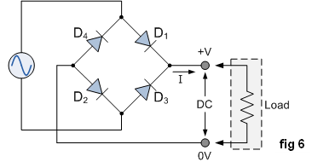
The four diodes labelled D₁ to D₄ are arranged in "series pairs" with only two diodes conducting current during each half cycle. During the positive half cycle of the supply, diodes D1 and D2 conduct in series while diodes D3 and D4 are reverse biased and the current flows through the load as shown below (fig 7).

The Positive Half-cycle
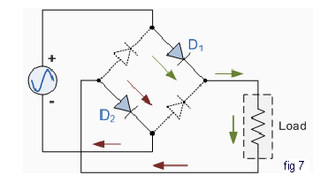

The Negative Half-cycle
During the negative half cycle of the supply, diodes D3 and D4 conduct in series (fig 8), but diodes D1 and D2 switch "OFF" as they are now reverse biased. The current flowing through the load is the same direction as before.

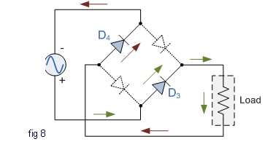

As the current flowing through the load is unidirectional, so the voltage developed across the load is also unidirectional the same as for the previous two diode full-wave rectifier, therefore the average DC voltage across the load is 0.637V_{max}. However in reality, during each half cycle the current flows through two diodes instead of just one so the amplitude of the output voltage is two voltage drops ( 2 x 0.7 = 1.4V ) less than the input V_{MAX} amplitude. The ripple frequency is now twice the supply frequency (e.g. 100Hz for a 50Hz supply)
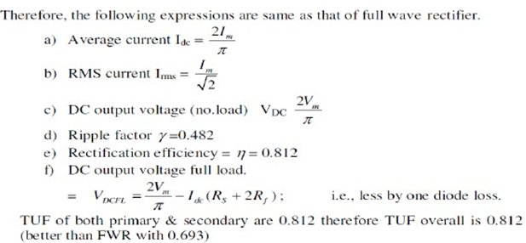

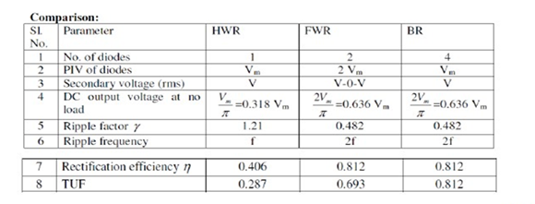
2.3 FILTERS
The output of a rectifier contains dc component as well as ac component. Filters are used to minimize the undesirable ac i.e., ripple leaving only the dc component to appear at the output.
Some important filters are:
- Inductor filter
- Capacitor filter
- LC or L section filter
- CLC or Π-type filter

2.3.1 CAPACITOR FILTER
This is the most simple form of the filter circuit and in this arrangement a high value capacitor C is placed directly across the output terminals, as shown in figure. During the conduction period it gets charged and stores up energy to it during non-conduction period. Through this process, the time duration during which Ft is to be noted here that the capacitor C gets charged to the peak because there is no resistance (except the negligible forward resistance of diode) in the charging path. But the discharging time is quite large (roughly 100 times more than the charging time depending upon the value of RL) because it discharges through load resistance RL.
The function of the capacitor filter may be viewed in terms of impedances. The large value capacitor C offers a low impedance shunt path to the ac components or ripples but offers high impedance to the dc component. Thus ripples get bypassed through capacitor C and only dc component flows through the load resistance RL
Capacitor filter is very popular because of its low cost, small size, light weight and good characteristics.
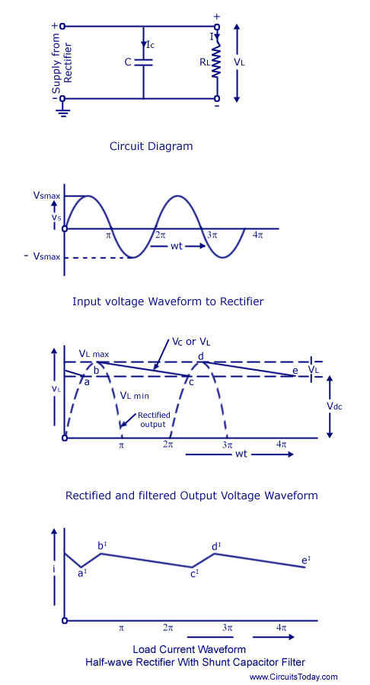

CAPACITOR FILTER WITH HWR
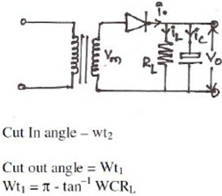

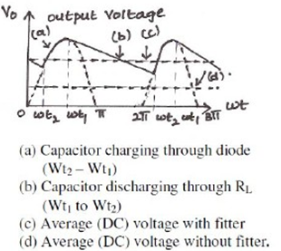
CAPACITOR FILTER WITH FWR
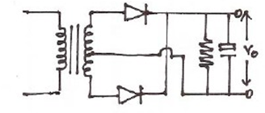
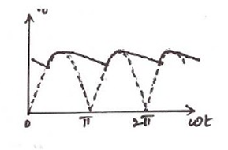
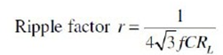
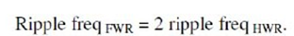
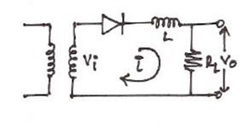
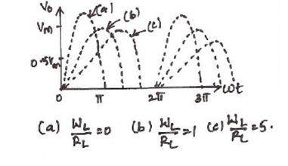

The worthnoting points about shunt capacitor filter are:
1.For a fixed-value filter capacitance larger the load resistance RL larger will be the discharge time constant CRL and therefore, lower the ripples and more the output voltage. On the other hand lower the load resistance (or more the load current), lower will be the output voltage.
2.Similarly smaller the filter capacitor, the less charge it can hold and more it will discharge. Thus the peak-to-peak value of the ripple will increase, and the average dc level will decrease. Larger the filter capacitor, the more charge it can hold and the less it will discharge. Hence the peak-to-peak value of the ripple will be less, and the average dc level will increase. But, the maximum value of the capacitance that can be employed is limited by another factor. The larger the capacitance value, the greater is the current required to charge the capacitor to a given voltage. The maximum current that can be handled by a diode is limited by the figure quoted by the manufacturer. Thus the maximum value of the capacitance, that can be used in the shunt filter capacitor is limited.

2.3.2 Series Inductor Filter.
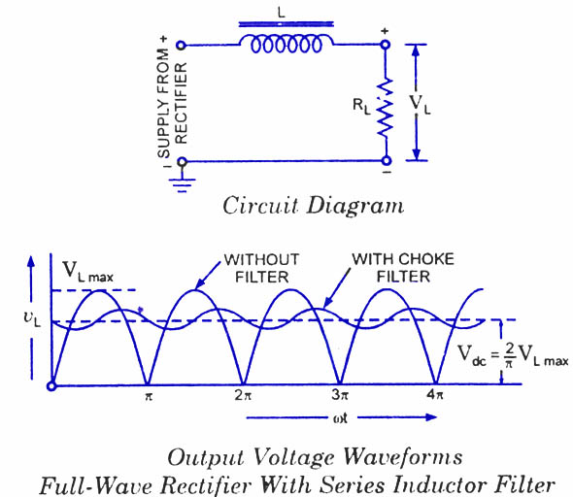
In this arrangement a high value inductor or choke L is connected in series with the rectifier element and the load, as illustrated in figure. The filtering action of an inductor filter depends upon its property of opposing any change in the current flowing through it. When the output current of the rectifier increases above a certain value, energy is stored in it in the form of magnetic field and this energy is given up when the output current falls below the average value. Thus by placing a choke coil in series with the rectifier output and load, any sudden change in current that might have occurred in the circuit without an inductor is smoothed out by the presence of the inductor L.
The function of the inductor filter may be viewed in terms of impedances. The choke offers high impedance to the ac components but offers almost zero resistance to the desired dc components. Thus ripples are removed to a large extent. Nature of the output voltage without filter and with choke filter is shown in figure.
For dc (zero frequency), the choke resistance R_{c} in series with the load resistance R_{L} forms a voltage divider and dc voltage across the load is given as
where V_{dc} is dc voltage output from a full-wave rectifier. Usually choke coil resistance Rc, is much small than R_{L} and, therefore, almost entire of the dc voltage is available across the load resistance R_{L}.
Since the reactance of inductor increases with the increase in frequency, better filtering of the higher harmonic components takes place, so effect of third and higher harmonic voltages can be neglected.
As obvious from equation , if choke coil resistance R_{c} is negligible in comparison to load resistance R_{L}, then the entire dc component of rectifier output is available across 2 R_{L} and is equal to — V_{L} _{max}. The ac voltage partly drops across X_{L} and partly over R_{L}.
2.3.3 L-SECTION FILTER:
A simple series inductor reduces both the peakand effective values of the output current and output voltage. On the other hand a simple shunt capacitor filter reduces the ripple voltage but increases the diode current. The diode may get damaged due to large current and at the same time it causes greater heating of supply transformer resulting in reduced efficiency.
In an inductor filter, ripple factor increases with the increase in load resistance RL while in a capacitor filter it varies inversely with load resistance RL.
From economical point of view also, neither series inductor nor shunt capacitor type filters are suitable.
Practical filter-circuits are derived by combining the voltage stabilizing action of shunt capacitor with the current smoothing action of series choke coil. By using combination of inductor and capacitor ripple factor can be lowered, diode current can be restricted and simultaneously ripple factor can be made almost independent of load resistance (or load current). Two types of most commonly used combinations are choke-input or L-section filter-and capacitor-input or Pi-Filter.
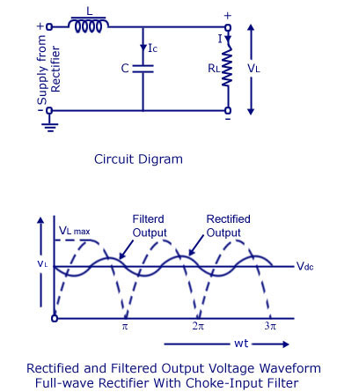

Choke-input filter is explained below:
Choke-input filter consists of a choke L connected in series with the rectifier and a capacitor C connected across the load . This is also sometimes called the L-section filter because in this arrangement inductor and capacitor are connected, as an inverted L. ln figure only one filter section is shown. But several identical sections are often employed to improve the smoothing action. (The choke L on the input side of the filter readily allows dc to pass but opposes the flow of ac components because its dc resistance is negligibly small but ac impedance is large. Any fluctuation that remains in the current even after passing through the choke are largely by-passed around the load by the shunt capacitor because Xc is much smaller than RL. Ripples can be reduced effectively by making XL greater than Xc at ripple frequency. However, a small ripple still remains in the filtered output and this is considered negligible if it than l%. The rectified and filtered output voltage waveforms from a full-wave re with choke-input filter are shown in figure.

2.3.4 Π-SECTION FILTER:
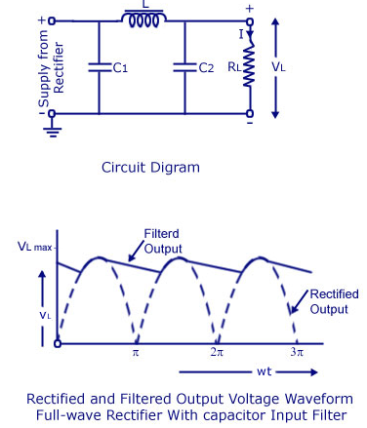
Capacitor-Input or Pi-Filter.
Such a filter consists of a shunt capacitor C1 at the input followed by an L-section filter formed by series inductor L and shunt capacitor C₂. This is also called the n-filter because the shape of the circuit diagram for this filter appears like Greek letter n (pi). Since the rectifier feeds directly into the capacitor so it is also called capacitor input filter.
As the rectified output is fed directly into a capacitor C1. Such a filter can be used with a half-wave rectifier (series inductor and L-section filters cannot be used with half-wave rectifiers). Usually electrolytic capacitors are used even though their capacitances are large but they occupy minimum space. Usually both capacitors C1 and C₂ are enclosed in one metal container. The metal container serves as, the common ground for the two capacitors.
A capacitor-input or pi- filter is characterized by a high voltage output at low current drains. Such a filter is used, if, for a given transformer, higher voltage than that can be obtained from an L-section filter is required and if low ripple than that can be obtained from a shunt capacitor filter or L-section filter is desired. In this filter, the input capacitor C1 is selected to offer very low reactance to the ripple frequency. Hence major part of filtering is accomplished by the input capacitor C1. Most of the remaining ripple is removed by the L-section filter consisting of a choke L and capacitor C₂.)
The action of this filter can best be understood by considering the action of L-section filter, formed by L and C₂, upon the triangular output voltage wave from the input capacitor C₁ The charging and discharging action of input capacitor C1 has already been discussed. The output voltage is roughly the same as across input capacitor C1 less the dc voltage drop in inductor. The ripples contained in this output are reduced further by L-section filter. The output voltage of pi-filter falls off rapidly with the increase in load-current and, therefore, the voltage regulation with this filter is very poor.
SALIENT FEATURES OF L-SECTION AND PI-FILTERS.
1. In pi-filter the dc output voltage is much larger than that can be had from an L-section filter with the same input voltage.
2.In pi-filter ripples are less in comparison to those in shunt capacitor or L-section filter. So smaller valued choke is required in a pi-filter in comparison to that required in L-section filter.
3.In pi-filter, the capacitor is to be charged to the peak value hence the rms current in supply transformer is larger as compared in case of L-section filter.
4.Voltage regulation in case of pi-filter is very poor, as already mentioned. So n-filters are suitable for fixed loads whereas L-section filters can work satisfactorily with varying loads provided a minimum current is maintained.
5.In case of a pi-filter PIV is larger than that in case of an L-section filter.

COMPARISON OF FILTERS
1) A capacitor filter provides Vm volts at less load current. But regulation is poor.
2) An Inductor filter gives high ripple voltage for low load currents. It is used for
high load currents
3) L – Section filter gives a ripple factor independent of load current. Voltage
Regulation can be improved by use of bleeder resistance
4) Multiple L – Section filter or π filters give much less ripple than the single L –
Section Filter.

